CtDatabank v2 – Clinical Trials Dispensing Management System

CtDatabank is a hosted, web-based system that will enable pharmacy departments to manage drug dispensing records in clinical trials.

CtDatabank
- is configurable to suit resources and working practices
- has strictly defined access and functionality
- aids GCP and compliance
- enables remote access, 24x7, to trial dispensing data
- reduces physical storage and reliance on paper and folders

See website for more details www.ctdatabank.com

Hospital pharmacy departments, of all sizes, run clinical trials on behalf of pharmaceutical companies, charities and their own R&D departments. It is vital to monitor patients, dispensing, drugs, stock levels, documentation and finance.

In keeping with clinical and information governance, good records must be kept. Electronically capturing dispensing records is non-trivial; accordingly, the replacement of a familiar paper-based, or ‘home-made’ system with an external database may be seen as a risk. However, access to high quality information in a consistent format is a compelling replacement.

CtDatabank was conceived in the UK as part of a national initiative to modernise the way clinical trial information is stored and managed. Originally designed in conjunction with a major UK teaching hospital, CtDatabank provides benefits for many users.

Benefits
CtDatabank is web-based and accessed on PCs, laptops and tablets. Intended for pharmacy and industry users alike, CtDatabank provides robust record keeping and follows standard procedures. CtDatabank can boost productivity and improve accuracy by validating some inputted data. Records can be searched and reports quickly generated.

Typical benefits for stakeholders include:

Pharmacy staff
- reduction in admin / increased efficiency
- consistency and uniformity of process
- accountability and ease of use

Pharmaceutical companies / industry
- offers real-time monitoring and feedback options
- data analysis potential with less data transcription errors

R&D
- provides a single repository for clinical data
- generates periodic invoices
- renders a Trust more desirable to commercial sponsors

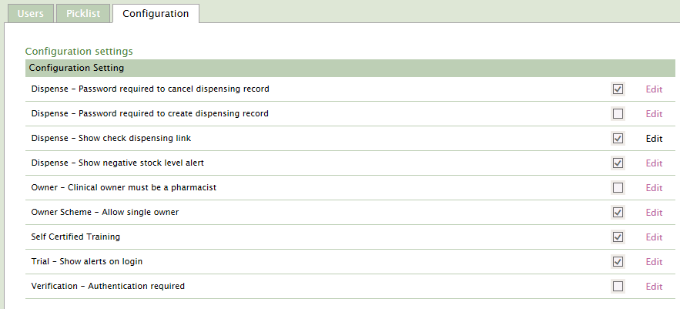
Configuration & Setup
CtDatabank has many configuration settings that reflect the working practices at an organisation.

These include the staff profiles required to set up a trial; training log usage; alert message display and password requirements during verification and drug dispensing.

CtDatabank uses a number of main tabs to store individual trial information - Setup, Dispense, Patients, Drugs, Admin, Finance and Documents.

An assigned admin owner sets up the structure for each new trial. Within ‘Setup’, other tabs store the clinical and GCP content which must be verified. Some of these are fixed and mandatory; others can be edited once the trial is active.

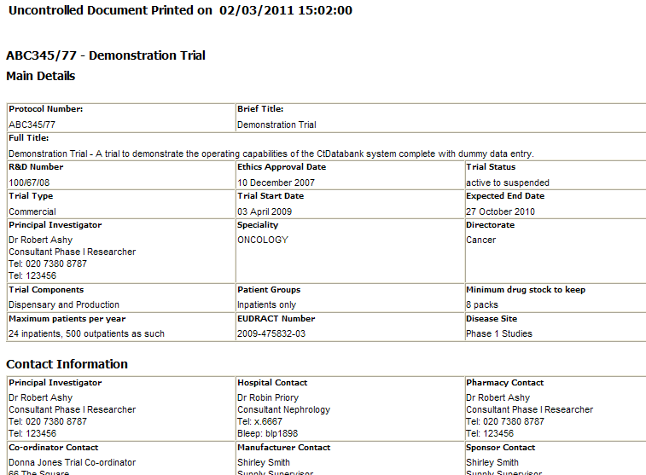
Main - The essential details for each trial are entered in this section - including the trial Name, Description and Protocol number. Also included are Approval and Start/End dates, the trial status, directorate, disease site, patient numbers and minimum stock levels.

Contact - The names and contact details of these people are entered – Principal Investigator and contacts names for the Hospital, Pharmacy, Co-ordinator, Manufacturer and Sponsor.

Clinical - This section contains specific information about the trial design and objectives. These include the drug, visit schedule, dose regime, counselling information and important details of the code break. Rich text tools provide flexible content to include table and graphics.

Dispensing - Stores the name, form, strength and pack size of the drugs involved in the trial. The issuing procedure is listed in some detail – pictures and diagrams are permitted. Storage and drug return/destruction details may be included.

Ordering -Supply and receipt information may be entered.

Patients
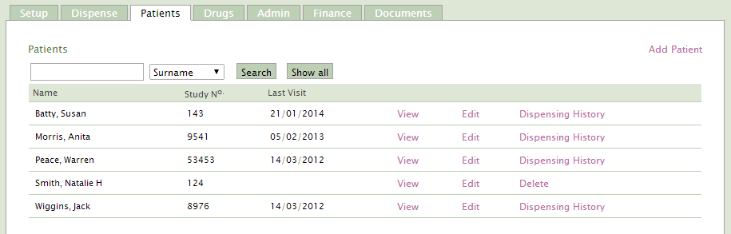
Enrolled patient records include name, hospital and study numbers, date of birth (and withdrawal). Monitors have a restricted view of this personal data.

There are also links to view the dispensing history for each patient. A configuration setting anonymises patient data for a trial if required.

Drugs and stock
All of the drugs used in the trial must be recorded and a drug record form is required for each drug/strength combination. A drug form is in three sections. Firstly, the name, IMP status, form and strength details, stock and dispensing units. Storage notes and location are available; finally the supply source and unit price enable invoices to be generated and financial reports to be generated.

Where required, an initial stock level for each drug is set up before it can be dispensed. As the trial progresses and drugs are dispensed, its stock level must be monitored. A stock report, showing all dates and quantities, lists all stock movements i.e. patient issue and stock replenishments.

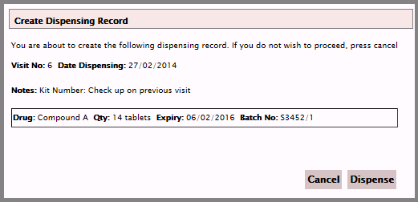
Dispensing
Drugs dispensed to a patient are recorded capturing their name, the date, visit no, drug, quantity and batch no. Only those drugs assigned to this trial are displayed for dispensing purposes. Stock levels are adjusted where necessary.

History
Once the dispensing record has been successfully created, it will always be linked to the patient. A dispensing record can then be edited, checked, cancelled or have returns recorded for audit purpose.

Invoicing
There is an option to record trial costs and dispensing fees in CtDatabank. The initial costs (based upon the NIHR template) should be entered by the trial invoicing owner.

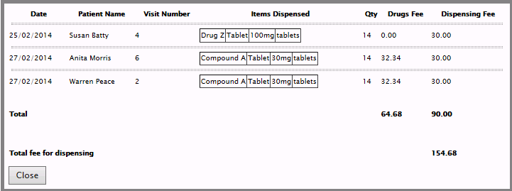
Invoices subsequently generated are submitted to trial sponsors as required - usually at the set up stage and then at regular intervals during the trial to cover dispensing costs and pharmacy stocks. Reminders ensure that nothing is missed. Financial reports summarise costs and expenditure.

Invoices also include a breakdown of the individual dispensing costs for a period.

Documents
It is possible to upload and centrally store associated documents and image files for a trial - often in the secure .pdf format. These might be created internally or be obtained from the sponsor and typically include the trial protocol document, investigator brochure and order forms. Each document is given a title and description. Documents can be opened and used simultaneously by multiple users – something paper cannot emulate.

Admin
A trial in CtDatabank will be in one of several stages including:

Proposed - Pending - Active – Closed (and also Rejected - Suspended)

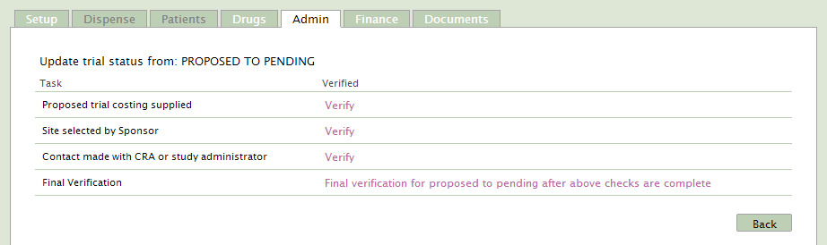
Independent verification checks are built into the system at each stage to ensure no process is overlooked.

Each process requires a trial Owner to initially verify the data content or later changes.

Active trials are used most frequently but trials in other states can be viewed depending upon the user’s access group.

Technology and Delivery
CtDatabank is hosted at a secure remote location. Access to data, using data encryption, is provided via the Internet using a standard browser like IE or Chrome. A helpdesk service is available to users during normal weekday working hours.

CoAcS make updates to CtDatabank as required. These will be applied to the system so that all users are transparently ‘upgraded’ together. All changes will be extensively tested and be compatible with all Trusts’ existing live data. Updates include features that users suggest or that improved technology provides.

About CoAcS
CtDatabank v2 – Clinical Trials Dispensing Management System

CoAcS is a private limited company founded in 1992, with offices in the UK, Australia and the UAE. Our software division develops, publishes and markets software for an international client base of customers – including hospitals, pharmacies, universities and pharmaceutical companies.

===================================================

Contact details

Registered Office: Kimbolton House, Mount Beacon, Lansdown, Bath, BA1 5QP, UK
Tel +44 (0) 1225 312992 Email: info@ctdatabank.com
URL: http://www.coacs.com

